Hawaiʻi Stream Index of Biological Integrity (HS-IBI) Data Form

Name: ___________________________________________ Date: _______________________________

School:___________________________________ Teacher’s Name:_____________________________

Sampling Date:________________ Stream:_________________________________________________

Study Site Location Name:_____________________________________ Elevation (bottom):__________

Latitude (bottom):_________________________ Longitude (bottom):___________________________

Background
The Hawai‘i Stream Index of Biological Integrity (HS-IBI) utilizes five ecological categories (taxonomic richness, sensitive species, reproductive capacity, trophic–habitat capacity, and tolerance capacity) and 11 metrics to distinguish a stream’s biological condition on a scale ranging from undisturbed to severely impaired. A framework comprised of five “integrity classes” (excellent–good–fair–poor–impaired) is provided, which can be used to translate a stream’s HS-IBI score into a verbal and visual portrait of its biological condition. The HS-IBI are appropriate for application in all perennial streams in Hawaii and may be adapted for use in streams on other tropical Pacific islands where native species assemblages persist in near-pristine stream environments.

[Source: Kido, M.H. 2013. A native-species based Index of Biological Integrity for Hawaiian
Stream Environments. Environmental Monitoring and Assessment 185 (5): 4063-4075.]

Procedure
Using the data collected from your study site, follow the directions provided throughout the data sheet for each of the five ecological categories to assign a subscore of 1, 3, or 5 for each metric. Use Table 1 on Page 2 to identify native and alien taxa. Exclude Cane toad (tadpoles) and Softshell turtle from your data if applicable. On Page 8, find the sum of your calculated subscores to determine your final HS-IBI score as a percentage. Note that the lowest final score you can get is 11 or 20% and the highest score you can get is 55 or 100%. Table 15 on Page 9 can be used to determine the “Integrity class” of your study site based on your final score.

Table 1. Native and alien stream fauna
Common Name | Species | Origin
Aholehole | Kuhlia sandvicensis | Native
Hapawai | Neritina vespertina | Native
Hīhīwai | Neritina granosa | Native
ʻOʻopu akupa | Eleotris sandwicensis | Native
ʻOʻopu alamoʻo | Lentipes concolor | Native
ʻOʻopu nākea | Awaous stamineus | Native
ʻOʻopu naniha | Stenogobius hawaiiensis | Native
ʻOʻopu nopili | Sicyopterus stimpsoni | Native
ʻŌʻpae kalaʻole | Atyoida bisulcata | Native
ʻŌʻpae ʻoehaʻa | Macrobrachium grandimanus | Native
Apple snail | Pomacea spp. | Alien
Asiatic clam | Corbicula fluminea | Alien
Banded jewel cichlid | Hemichromis elongatus | Alien
Blackchin tilapia | Sarotherodon melanotheron | Alien
Bristlenose catfish | Ancistrus sp. | Alien
Chinese Catfish | Clarius fuscus | Alien
Convict cichlid | Amatitlania nigrofasciata | Alien
Guppy | Poecilia reticulata | Alien
Japanese swamp shrimp | Neocaridina denticulate sinensis | Alien
Malaysian trumpet snail | Melanoides tuberculata | Alien
Molly | Poecilia sphenops | Alien
Red swamp crayfish | Procambarus clarkii | Alien
Smallmouth bass | Micropterus dolomieu | Alien
Swordtail | Xiphophorus helleri | Alien
Suckermouth catfish | Hypostomus sp. | Alien
Tahitian prawn | Macrobrachium lar | Alien

CATEGORY A. TAXONOMIC RICHNESS
Metric 1: “Number of native amphidromous macrofauna” assesses species richness in its simplest form as direct counts of the number of native aquatic species found in study site. Use EITHER Table 2a or Table 2b, NOT BOTH, to determine points for Metric 1. If your study site was either at Kaimuki High School or Manoa-Palolo Confluence, use Table 2b. For any other location, use Table 2a.

Table 2a. Native species present (Non-estuary) Table 2b. Native species present (Estuary)
Number of non-estuary native species | Points
Reference Table
If your “Number of non-estuary native species” is | Then use this subscore
3-4 | 5
1-2 | 3
0 | 1

Number of estuary reach native species | Points
Reference Table
If your “Number of estuary reach native species” is | Then use this subscore
5-6 | 5
2-4 | 3
0-1 | 1

Metric 2: “Percent contribution of native taxa” is a form of species richness measure and is equivalent to Simpson’s Diversity Index.

Table 3. Use the table below to list the percent of native taxa at your site
% of native taxa | Points
Reference Table
If your “% of native taxa” is | Then use this subscore
75-100% | 5
50-74% | 3
$≤$49% | 1

Metric 3: “Number of alien taxa” is correlated with decreasing habitat quality and increasing human disturbance. Taxa refers to different types of organisms (often species) and not counts of individuals.

Table 4. Use the table below to list the number of alien taxa at your site.
Number of alien taxa | Points
Reference Table
If your “Number of alien taxa” is | Then use this subscore
0-1 | 5
2-3 | 3
>3 | 1
CATEGORY B. SENSITIVE “SENTINEL” SPECIES

Metric 4. “Percent sensitive native fishes” are species highly sensitive to environmental degradation and thus are reliable indicator species for assessments of biotic integrity. In Hawaiian Streams, sensitive native species are Lentipes concolor-ʻoʻopu alamoʻo and Sicyopterus stimpsoni-ʻoʻopu nopili.

Table 5. Use the table below to list the percent of sensitive native fish at your site
% of sensitive native fishes | Points
$\frac{sensitive native species}{total species}×100$

Reference Table
If your “% of sensitive native fish” is | Then use this subscore
$≥$50% | 5
49-20% | 3
$≤$19% | 1

Metric 5. “Sensitive native fish density” is used to verify absolute densities of Lentipes concolor (ʻoʻopu alamoʻo) and Sicyopterus stimpsoni (ʻoʻopu nopili), as it may not always coincide with high proportionate abundance of sensitive species found in Metric 4.

Table 6. Use the tables below to list the sensitive native fish density at your site. Assign a subscore of 1 unless instructed otherwise (most sites on Oʻahu have a very low sensitive native fish density).
Sensitive native fish density (fish/m²) | Points
Reference Table
If your “Sensitive native fish density (fish/m²)” is | Then use this subscore
$≥$0.46 | 5
0.20-0.45 | 3
$≤$0.19 | 1

CATEGORY C. REPRODUCTIVE CAPACITY

Metric 6. “Sensitive native fish size” in a sample population is used as an overall indicator of community health, as size is a relatively influenced by both environmental (e.g. food availability / quality, pollution, stressors, etc.) and population / community factors (e.g. predation, competition, disease, etc.).

* Sensitive native species are Lentipes concolor-ʻoʻopu alamoʻo and Sicyopterus stimpsoni-ʻoʻopu nopili
* Sensitive native fish size is measured in total length (mouth to end of tail)
* Exclude post-larval size classes (fish that are $≤$3.0 cm in total length)

Table 7. Use the table below to list the percent of sensitive native fish $≥$6.0 cm at your site. Assign a subscore of 1 unless instructed otherwise (most Oʻahu sites have very low sensitive native fish density).
Sensitive native fish size  (% $≥$6.0 cm in total length) | Points
$\frac{Sensitve native species ≥6.0 cm}{Total sensitive species}×100$
Reference Table
If your “Sensitive native fish size (% $≥$6.0 cm in total length)” is | Then use this  subscore
$≥$50% | 5
49-25% | 3
$≤$24% | 1

Metric 7. “Awaous stamineus (‘o‘opu nākea) size.” As a moderately tolerant species to environmental degradation, ‘o‘opu nākea often overlaps in distribution within / between streams with the two sensitive species in Metrics 5 and 6, but is also found in streams with higher levels of human disturbance. As a generalist feeder (omnivore), ‘o‘opu nākea size is also a useful indicator of food availability and habitat quality.

* Awaous stamineus size is measured in total length (mouth to end of tail)
* Exclude post-larval size classes (fish that are $≤$3.0 cm in total length)

Table 8. Use the tables below to list the percent of Awaous stamineus-ʻoʻopu nakea ≥ 8.0 cm at your site. Assign a subscore of 1 if no -ʻoʻopu nakea were found, as 0 % is still in the lowest subscore category.

Awaous stamineus size  (% ≥ $8$.0 cm in total length) | Points
$\frac{Awaous stamineus ≥8.0 cm}{Total Awaous stamineus}×100$
Reference Table
If your “Awaous stamineus size  (% ≥ $8$.0 cm in total length)” is | Then use this  subscore
$≥$50% | 5
49-25% | 3
$≤$24% | 1

CATEGORY D. TROPHIC / HABITAT CAPACITY

Metric 8. “Total native fish density” uses native fishes (and invertebrates) as an indicator of stream biotic integrity and supports metric 5, where higher densities correlate with more natural ecological functioning, environmental quality, lower number of alien species, and reduced human disturbance.
Table 9. Use the tables below to list the total native fish density at your site. Assign a subscore of 1 unless instructed otherwise (most sites on Oʻahu have a very low total native fish density).

Total native fish density  (total native fish/m²) | Points
Reference Table
If your “Total native fish density  (total native fish/m²)” is | Then use this subscore
$≥$0.75 | 5
0.74-0.36 | 3
$≤$0.35 | 1

Metric 9. “Community weighted average” is a numerical expression that reflects the relative sensitivity of various taxa to habitat degradation and the relative individuals in each taxon in a sample. The CWA is calculated as the sum of the proportionate numerical abundances of individual taxa in the sampled population multiplied by their respective weighting values.

Table 10a. CWA weighting values for stream species Table 10b. Calculated CWA Example
Species | Common Name | Weighting value
Lentipes concolor | ʻOʻopu alamoʻo | 1
Sicyopterus stimpsoni | ʻOʻopu nopili | 1
Neritina granosa | Hīhīwai | 2
Atyoida bisulcata | ʻŌʻpae kalaʻole | 3
Macrobrachium grandimanus | ʻŌʻpae ʻoehaʻa | 3
Stenogobius hawaiiensis | ʻOʻopu naniha | 3
Awaous stamineus | ʻOʻopu nākea | 4
Eleotris sandwicensis | ʻOʻopu akupa | 4
Kuhlia sandvicensis | Aholehole | 4
Macrobrachium lar | Tahitian prawn | 9
Alien species (other than M. lar / Tahitian prawn) |  | 10
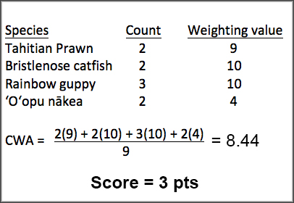

Table 10c. Use the tables below to list the community weighted average (CWA) at your site
Community weighted average (CWA) | Points
Reference Table
If your “Community weighted average (CWA)” is | Then use this subscore
1.0-4.0 | 5
4.1-9.0 | 3
9.1-10 | 1

CATEGORY E. TOLERANCE CAPACITY

Metric 10. “Percent tolerant alien fish” describes the introduced species of fish that have established populations in Hawaiian Streams, even those that have been heavily disturbed by humans. These include all alien species listed in Table 1. Their presence is detrimental to native fishes because of direct predation, increased competition for resources, increased habitat degradation, and vectors of disease and parasites.

Table 11. Use the tables below to list the percent of tolerant alien species at your site
% tolerant alien species | Points
$\frac{Number of alien species}{Total number of species}×100$
Reference Table
If your “% tolerant alien  species” is | Then use this subscore
0% | 5
1-4% | 3
≥5% | 1

Metric 11. Percent diseased / Parasitized Fish evaluates the stream biological condition at the level of the individual, where habitat quality is correlated with the incidence of lesions and parasites on fishes and benthic invertebrates.

Table 12. Use the table below to list the percent of diseased or parasitized fish at your site. Assign a subscore of 5 unless instructed otherwise (most sites have a low % of diseased of parasitized fish)
% diseased or parasitized fish | Points
Reference Table
If your “% diseased or parasitized fish” is | Then use this subscore
≤1% | 5
2-10% | 3
≥11% | 1

Table 13. Determine the final HSIBI score by adding points from Metrics 1-11, then calculate percentage:
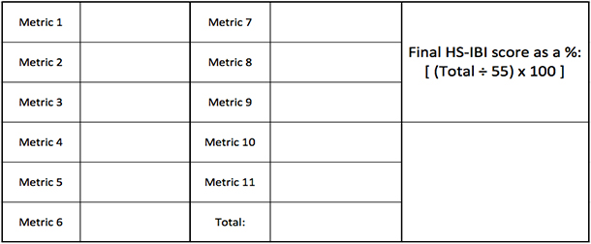

Table 14. Use the data and HS-IBI score collected at Kanewai Field in Manoa Stream on 1/19/17 as an example to check your work
Origin | Organism Type | Species | Common Name | Count | Size Range (cm) | Biomass Estimate (lbs) | Approx. HSIBI
Non-Native | Vertebrate | Ancistrus temminckii | Bristlenose / Bushynose Plecostomus | 16 | 5 | 0.30 | 27.30
Non-Native | Vertebrate | Hypostomus watwatta | Suckermouth Catfish / Plecostomus | 11 | 10
Non-Native | Invertebrate | Procambarus clarkii | Swamp Crayfsih | 1 | 5

Table 15. Circle the integrity class of your stream site using your calculated Final HS-IBI % score
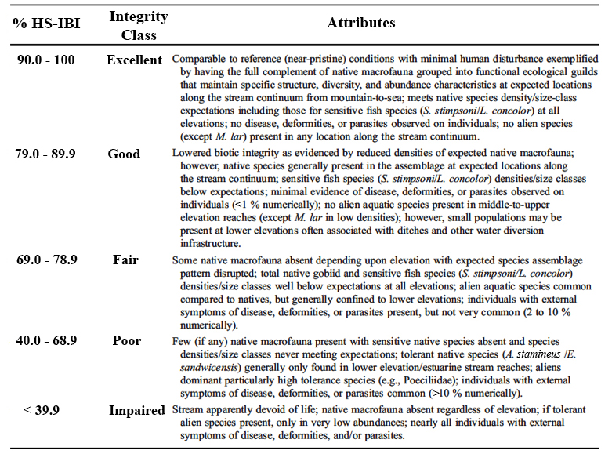
Modified table from Kido, 2012.

